# ES2660 Panel Discussion Planning Notes

This is a basic structure which teams are encouraged to make fit for their purpose.

|  |  |
| --- | --- |
| Basic Structure | Guiding Questions based on Barrett’s Taxonomy to mine for meaning |
| * Introductory material : cf Barrett’s level 1 and 2   + Panellists and POV   + Topic and specific focus   + Reason for interest   + Prompt to be addressed   + Definition of key words   + Outline of discussion * Body: cf Barrett’s level 3, 4, 5   + Main points covered   + Focus – level 5 – implications and insights likely to come from here * Conclusion   + Quick summary   + Tentative or overall conclusion   + Address prompt given by tutor   + Further thought provoking question   + Invite questions * Q and A   + Take questions from audience   + Final word and close discussion | Level 1 –Greeting_____________________________  Today our panel comprises___________________________________They represent different perspectives on _____________(topic and focus). Why should the audience be interested in today’s discussion?_____________________________  Level 2 –  Level 3-  Level 4-  Level 5 - |

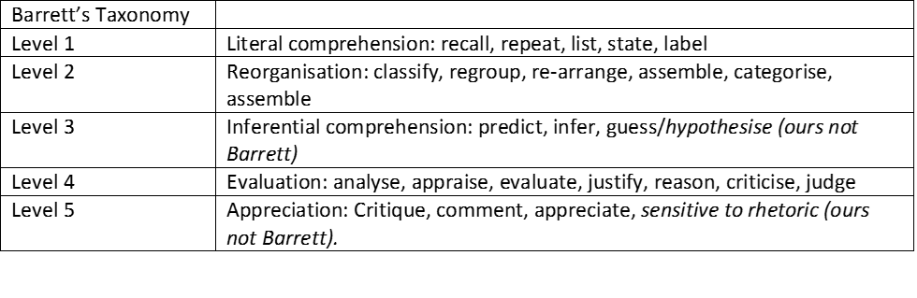

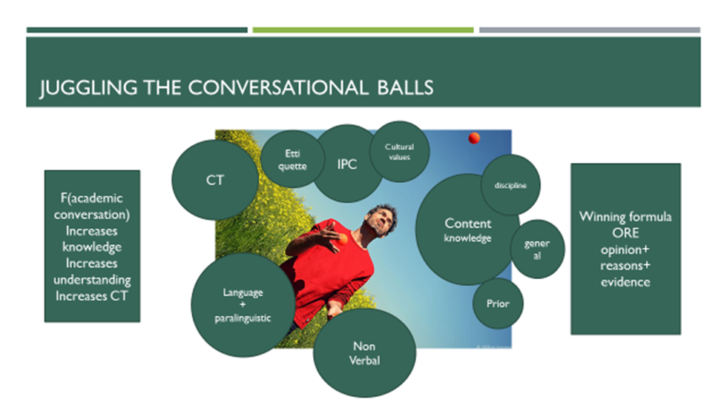

**Revision Quiz**

1. **How do you show you are engaged with each other nonverbally?**
2. **How can you show you are engaged with each other’s points, verbally?**
3. **What kinds of questions can you ask?**
4. **What is the function of each kind of question in furthering the discussion?**
5. **How long should you hold the floor for?**
6. **How can you interrupt?**
7. **What are some words and phrases to express disagreement?**
8. **Is it important that everyone agrees at the end of the discussion?**
9. **What is a good way to end the discussion?**
10. **What are some good strategies for handing Q and A?**